Long Distance DC Transmission of Green Power
Steven Eckroad, Electric Power Research Institute, Charlotte, NC, USA
Dr. Adela Marian, Institute for Advanced Sustainability Studies, Potsdam, Germany

The Environmental Challenge

Energy generation from renewable sources, for instance solar, wind, geothermal and tidal, is increasingly regarded as an important priority in many regions of the world. The areas with abundant green energy sources are typically located far (up to several thousand kilometers) from the major consumption centers, posing new challenges for efficient long-distance transmission systems. A prominent example is the case of China, where 35 high-power HVDC projects are envisaged for the 2010-2020 decade with a total transmission capacity of 217 GW. Most of these projects are being built to allow the energy generated by hydro plants located in the geographical center of the country to be transported to the densely populated southern and eastern regions.

In addition to the exemplified need for green energy due to growing demand, there is also the explicit choice of green energy in favor of other cheaper alternatives, as a response to environmental concerns. For instance, following the nuclear accident at Fukushima in March 2011, Germany decided to phase out nuclear power and gradually transition towards an increasingly larger fraction of renewables in the national energy mix. The plan is to have 35% renewables in the electricity mix by 2020, 50% by 2030, 65% by 2040 and finally 80% by 2050. This is also in agreement with the so-called ’20-20-20’ objectives of the European Union, which target the reduction in greenhouse gas (GHG) emissions by 20% as compared to their 1990 levels, the development of renewable energies so as to account for 20% of the European energy consumption, and an improvement in energy efficiency of 20% by 2020.

In the United States there is no national renewables program, but the current US administration has announced its intention to reduce GHG emissions some 17 percent below 2005 levels by 2020 and up to 83 percent by 2050. While the US does not have a national target for GHG reduction, many states do. State targets differ from one state to another as to the amount and timing: programs range from 10% to over 30% over the next 10 to 20 years. Together these comprise nearly half the electricity sales in the nation.

Besides the well-established photovoltaic, hydro, biomass, and wind energy, concentrated solar energy (CSP) is regarded with increasing interest in the European space, due to its proximity to the vast expanses of deserts in Northern Africa and the Middle East. Coupled with proper energy storage, this technology holds a lot of promise for efficiently collecting solar radiation in the sun-belt areas. As an example, it was calculated that a CSP field the size of Lake Nasser in Egypt (~ 6000 km²) could generate an amount of energy equivalent to the current Middle East oil production. In fact, taking the projected value of 5 MWh/year/person for the energy consumption in 2050, it can be shown that covering 1% of the world’s deserts with CSP collectors will be sufficient to meet the global energy needs.

Should large, green-power resources be tapped to serve growing load centers, innovative methods of transmitting GW-level power over long distances will be required. One way to accomplish this is to use lossless dc cables based on high-temperature superconductors. When compared to the standard overhead lines, the superconducting cables

will have no impact on the landscape due to their underground location,

would generate no stray electromagnetic fields that could affect the surrounding area,

would have a smaller environmental footprint than both overhead lines and standard underground cables,

would minimize the land use and property acquisition, leaving the value of local real estate unaffected, and

lastly, they would not be influenced by natural weather phenomena such as wind, fog, snow and ice.

Overview and Status of DC Superconducting Cables.

The continuing improvement in superconducting materials (zero-resistance materials) and recent successes for in-grid deployments of short-length superconducting ac cables, suggest that a very high power superconducting dc cable might be a possible and effective component of an electric power system. This is not a new idea, but rather one which only recently has achieved a practical possibility.

One of the earliest explorations of this idea was by two physicists, Garwin and Mattisoo, who in 1967 evaluated the possibility of transferring 100 GW over 1000 miles in a single superconducting dc power cable [1]. Their bold concept used the recently discovered superconducting compound, Nb₃Sn, and operated at about 4 K using liquid helium as a coolant – the only element that is a liquid at that temperature.

A few years later, work by engineers from the Los Alamos Scientific Laboratory (LASL), recognized the limitations and advantages of the flow of cryogens in a practical power transfer system, and combined multiple fuels as liquefied coolants with a superconducting dc cable. In particular, they incorporated the use of liquid hydrogen. Developing the scientific and engineering details over the next decade, the LASL team showed that a superconducting dc cable could be built and made to operate within a large ac power grid [2].

One conclusion from the LASL program was that achieving a practical device would require further developments in superconducting materials. Financial analysis indicated that a liquid helium cooled cable would be too expensive due to the high capital and operating cost of maintaining the operating temperature. Each watt of heat that enters the 4 K environment of the superconducting core requires about 500 W of electric refrigeration to remove. Additionally, the silicon-controlled rectifier (SCR) technology used in the ac–dc converter system was limited to currents of a few hundred amperes and required significant reactive power compensation at the receiving end of the transmission line.

These seminal works showed that, with the available materials and technology of the time, the concept was just not practical. However, the next three decades would see significant material discoveries and technology advances that would result in additional avenues for realizing practical systems.

One such advance was the 1986 discovery by Bednorz and Müller of high-temperature superconductivity (HTS) in ceramic materials [3]. These new materials operate at liquid nitrogen temperatures (65 - 77 K), so that instead of a factor of 500 for the refrigerator’s power requirement, the factor is only about 20 – 25. Liquid nitrogen is plentiful, easy to obtain, and inexpensive. A second, more recent materials development was the 2001 discovery of superconductivity in magnesium diboride (MgB₂) [4]. These superconductors operate at temperatures lower than liquid nitrogen, but in a range that may be reached with liquid hydrogen or relatively inexpensive closed cycle cryocoolers.

In parallel with the development of superconductors, ac–dc power technology has evolved with higher-current and higher-power silicon-based devices. New topologies as well as control schemes now allow ac–dc converters to pattern the outgoing power to match variations in the current and voltage of the receiving power grid making them more flexible and smaller in physical size.

Starting in the mid-1990s the Electric Power Research Institute (EPRI) revisited the possibility of using the new superconductors for long distance, multi-GW power transmission. In 2001 EPRI researchers introduced a futuristic concept for large-scale bulk energy transfer with liquid hydrogen flow and a superconducting dc cable, nominally using the newly discovered MgB₂ superconductors (or HTS conductors) [5]. As a first step in that direction EPRI began developing the engineering details for a 10-GW, 1600-km superconducting dc cable operating at liquid nitrogen (LN) temperatures (see Figure 1). This four-year effort, completed in 2009, achieved a level of engineering design for a dc superconducting cable that demonstrated it to be ready for commercial development using current technology [6]. A principal recommendation of the work was to begin building prototypes, scaling up from laboratory sizes to realistic in-grid demonstrations, while resolving the remaining optimization issues for a practical system.
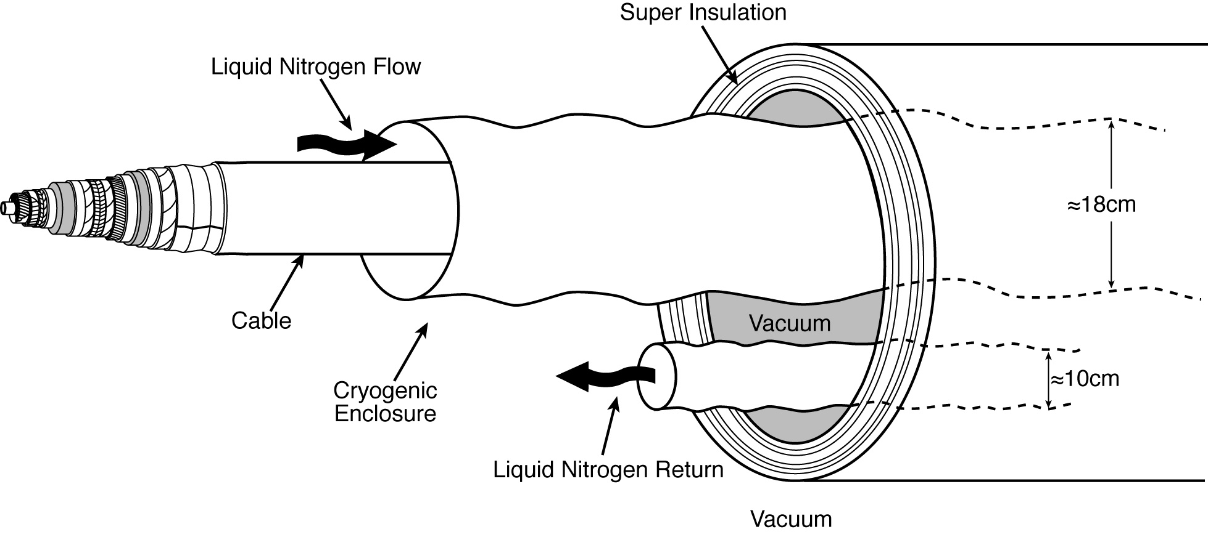
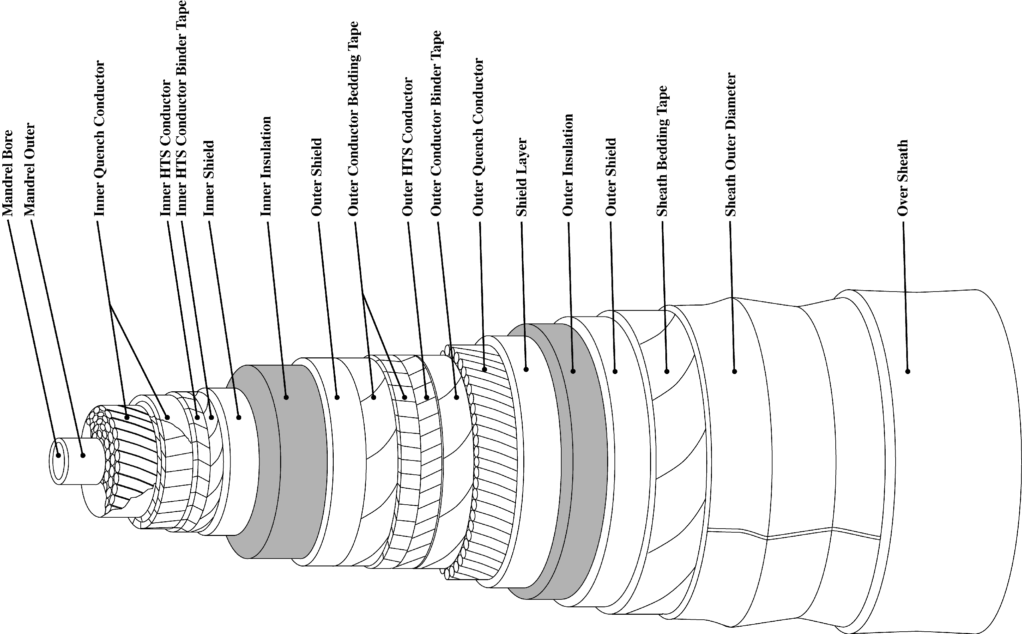

Figure 1 – EPRI superconducting dc cable

Advances in Science and Technology to Meet Challenges.

A dc superconducting cable is in many if not most of its critical design details similar to an ac superconducting cable. The technical feasibility of HTS ac cables has been proven by cable manufacturers in several countries through multiple demonstration projects, at medium and high voltage levels, with in-service grid experience greater than 5 years for some [7]. Building on this experience there has been recent good progress toward fabricating and demonstrating short-length, low power dc cables, following a variety of design approaches [8, 9].

The primary engineering design challenges for successful implementation of long-length dc superconducting transmission lines are related to the choice and cost of the materials (mainly the superconductor) and the design, cost and reliability of the cryogenic cooling systems. The latter includes both the refrigeration system and the thermal envelope (cryostat) between the superconductor and the outside environment.

The primary non-technical challenge to realization of such systems has to do with societal acceptance including both by those organizations charged with building and operating the lines (e.g., utility companies) as well as by the public at large, whether expressed through government advocacy or directly by public opinion, which may influence that advocacy, both negatively (e.g., safety concerns) as well as positively.

Technical and non-technical challenges are inter-related because utility company as well as public acceptance is in part based on equipment cost and performance and these in turn are linked to design choices and engineering success.

HTS superconductors are still too expensive to make long distance dc transmission a commercial reality, although new manufacturing processes currently being explored and continued improvement in yield and performance in existing processes could promise a continued reduction in cost. As well, current world-wide HTS production capacity is not capable of providing the needed quantity for a very long transmission cable.

MgB₂ wire offers an attractive low-cost alternative to HTS wire, with current costs one-tenth (or less) the cost of HTS. However, an MgB₂ cable must be cooled with either gaseous helium or liquid hydrogen at a temperature of about 20 K. As mentioned earlier, refrigeration capital and operating costs are a strong non-linear inverse function of temperature, and the cost of cryogenics for MgB₂ could potentially outweigh its lower material costs when compared to an HTS cable. Limited world supplies of helium have been a recent source of concern, and public acceptance of long “pipe-lines” filled with hydrogen may be problematic. Research and development addressing these and other issues for MgB₂ systems is underway [10, 11]. A comprehensive research initiative on high power, very long distance power lines based on MgB₂ is under investigation by the Institute for Advanced Sustainability Studies (IASS) in Potsdam, Germany [12].

Regardless of the wire choice, all cryogenic systems are large, complex and expensive. Commercial viability of dc cables will require lower costs and higher reliability from these systems to ensure cables remain in service. In addition, pumping cryogens over the long distances and varying altitudes envisioned presents unique hurdles. Instead of the custom engineered and fabricated systems deployed in demonstration projects suppliers must optimize, simplify and standardize cryogenic cooling hardware in the size range of interest for cables. Common cryogenic systems tend to either be much larger than the size needed for cables (e.g., air separation plants), or too small (e.g., equipment used by medical and academic institutions).

Conclusion

The advent of cost-effective, environmentally friendly superconducting dc transmissions lines linking abundant renewable and green energy resources with power-hungry, distant metropolises and energy consumers has a promising future. In the space of almost half a century first the concept, then the engineering details, and now the initial instances of actual demonstration have steadily occurred. However, advances in materials, cryogenics, and ac-dc conversion are still needed to make the dc superconducting cable both a reliable and cost-effective alternative to environmentally less favorable overhead transmission lines.

References
1 R. L. Garwin and J. Matisoo, “Superconducting Lines for the Transmission of Large Amounts of Electrical Power over Great Distances,” Proceedings of the IEEE, Vol. 55, No. 4, pp. 538–548 (1967).
2 F. J. Edeskuty et al., DC Superconducting Power Transmission Line Project at LASL: US DOE, Division of Electric Energy Systems. Los Alamos Scientific Laboratory, Los Alamos, NM: 1980. LA-8323-PR.
3 K. Alex Müller and J. Georg Bednorz, “The Discovery of a Class of High-Temperature Superconductors” Science, Vol. 237, No. 4819, pp. 1133–1139 (1987).
4 J. Nagamatsu, et al., “Superconductivity at 39K in Magnesium Diboride,” Nature 410, 63 (2001).
5 The Hydrogen Electric SuperGrid. EPRI, Palo Alto, CA: 2006. 1013089.
6 Program on Technology Innovation: A Superconducting DC Cable. EPRI, Palo alto, CA:2009. 1020458.
7 Superconducting Power Equipment: Technology Watch 2011. EPRI, Palo Alto, CA: 2011. 1021890
8 S. Yamaguchi, “Experiment of the 200-Meter DC Superconducting Power Cable,” IASS Workshop, Transporting Tens of Gigawatts of Green Power to the Market, Potsdam, Germany, May 12, 2011.
9 Liye Xiao, et al, “HTS Technology for Future DC Power Grid,” Presentation 1JB-02, Applied Superconductivity Conference, October 2012. Portland, USA.
10. V. S. Vysotsky, et al, “Hybrid Energy Transfer Line with Liquid Hydrogen and Superconducting MgB2 Cable – First Experimental Proof of Concept,” Presentation 2LA-01, Applied Superconductivity Conference, October 2012, Portland, USA.
11. A. Ballarino, “Design of an MgB2 Feeder System to Connect Groups of Superconducting Magnets to Remote Power Converters,” J.Phys. 234, 032003 (2010).
12. See, for example, http://www.iass-potsdam.de/research-clusters/earth-energy-and-environment-e3/scientific-program/long-distance-energy-transport.

