One Score and Ten Years Ago  
(Submitted for publication in the January 2016 issue of Cold Facts International)

Paul Michael Grant

W2AGZ Technologies

[w2agz@w2agz.com](mailto:w2agz@w2agz.com)

[www.w2agz.com](http://www.w2agz.com)

One score and ten years ago, or 30 years and counting in less Linconesque units, by late January, 1986, Georg Bednorz at IBM’s Rueschlikon Research Laboratory, glimpsed evidence of granular superconductivity spanning the 10 – 20 K range in a mixed phase sample of the copper oxide perovskite La4BaCu5O13 (aka La-4-1-5-13, for short).1 What followed was 18 months of intrigue reminiscent of the “double helix” period associated with the Watson-Crick discovery of the structure of DNA in 1953.

For more than a year, Bednorz had been working “off the clock,” under the guidance of his mentor, Alex Mueller, one of the pioneer IBM Fellows, who had hired him into IBM on completion of his graduate studies at ETH. For some time previously, Mueller had been intrigued by the speculations of B. K. Chakraverty (CNRS-Grenoble)2 and K.-H. Hoeck (TH-Darmstadt)3 that Jahn-Teller derived bipolarons might form the bosonic glue mediating “higher temperature superconductors.” The term “high temperature superconductivity (HTSC)” derives from a comment by Bernd Matthias of UCSD that such materials, should they indeed exist, would exceed the critical temperatures of the then known “A15” Nb-intermetallics (20-23 K range).

For several years prior to 1986, Mueller had served as an advisor to the CNRS program at the University of Marseilles on their efforts focused on aluminum and transition metal oxides, principally nickelate compounds. He recognized their electronic structure contained elements of the Jahn-Teller bipolaron model speculations of Chakraverty and Hoeck, and suggested to Bednorz he try preparing such systems to explore for potential “miracles,” mostly performed on “personal overtime” and not part of the “official” IBM Zuerich research agenda.

In mid- to late 1985, another CNRS group, at the University of Caen, led by Bernard Raveau, published in two relatively specialized and not widely read European journals on materials research, their cumulative work on a series of related companion compounds to the nickelates, copper oxides perovskites, as possible high temperature oxygen sensors for cement kilns!4 Bednorz found these papers in recently shelved journals in the IBM Zuerich library, and immediately recognized their possibilities as embodiments of the Mueller, Chakraverty and Hoeck vision. Concentrating on “4-1-5-13,” which is very difficult to synthesize in single phase (try it yourself sometime!), he found trace amounts of, most likely, barium doped La2CuO4-y, and a resistive transition eventually nearing 30 K.

This finding ignited another fascinating historical episode in the annals of condensed matter physics…what I like to term “climbing perovskite pillars.” From the first measurements in Zuerich, 30 years ago, through their “quiet” submission to Z. fur Phys. B in April, 1986, and its publication5 the following Fall and replication at U. Tokyo (Tanaka Group)6, IBM Yorktown (Greene, et al.)7, the University of Houston (Chu and Wu), and signs of transitions by the latter group in excess of 90 K8. However, the Zuerich team, in fact, were really the first to verify their own discovery. By early September, 1986, using SQUID magnetometry, they observed the Meissner Effect, results again “quietly” published in early 1987 in Europhysics Letters9 (see Fig. 1). By late February that year confirmation of high temperature superconductivity in various copper oxide compounds had been achieved by many groups worldwide, including our team at IBM Almaden Research, the first to correctly identify the positions of the cations in YBa2Cu3O7-y (aka, “Y-123” or “YBCO”)10. This last work resulted in the fundamental international materials processing patent underlying all copper oxide perovskite superconductors with Tc greater than the atmospheric boiling point of liquid nitrogen11.

All these events exploded on the world scene at the “Woodstock of Physics” APS March Meeting in mid-Manhattan and the following month during the April MRS Spring Meeting, which I dubbed to the press, “the Altamont of Materials” (in honor of the 1969 infamous Rolling Stones concert in the hills east of San Francisco), held in Anaheim near Los Angeles, a Time Magazine cover, and culminating in President Reagan’s May “White House Conference”12 which established the very successful (technically) 1987-2011 DOE Superconductivity Partnership Initiative. That era of hysteria was capped by the Spring 1988 PBS NOVA production, “Race for the Superconductor,”13 which won an Emmy for its producer (as well as the cast!).

What ensued next were several years of various news journal publications/speculations predicting novel paths to the Mecca of room temperature superconductors and anticipating the realization of the current discoveries as embodying the energy efficiency deliverance of mankind. As has been pointed out in several recent editorials in Cold Facts by yours truly (Cold Power14, June 2015; Coming in from the Cold15, 2014), we’re still waiting, despite two decades of successful demonstrations of HTSC power applications in cables, transformers, SMES and fault current limiters.16 Perhaps the most successful “commercial” application to date has been the “levitation kit” first built by my daughter Heidi as her 8th grade science project in April, 1987.17 It brings to mind the wisdom expressed in the closing paragraph of the Foner-Orlando 1988 February MIT progress report, “Superconductors: The Long Road Ahead:” “…a great deal remains to be done”18 …and still does. Incidentally, a component of the pavement of that road to be laid involves greater insight into the pairing mechanism of HTSC, still an open question, although most would agree that both phonons and and charge density and spin waves play a role, and we await the development of a density functional tool that would allow the computational design of new “perovskite pillars.”19

So what could be the eventual practical blessings bestowed by the Rueschlikon revelation?

My “crystal ball” reveals two possible scenarios:

* Exploring the Theory of Everything.

Most of my high energy physics colleagues point to the need for a next generation of “atom smashers” to explore the treasure trove of supersymmetry (“hierarchy”) beyond the Higgs boson. This is a “tall order,” and would require “large hadron colliders” with center-of-mass energies greater than 100 TeV (right now, the CERN LHC upgrade will top out at 14 TeV). Given the extremely high critical currents and fields of the copper oxide perovskites at low temperatures (HC2 at 4 K has yet to be measured in YBCO), extremely powerful and compact deflection electromagnets are now possible to construct and deploy. However, the vision I prefer is this:

At the “turn of the last century,” a team at FermiLab led by Peter Limon, Ernie Malamud and Bill Foster (Foster now serves in the US House of Representatives) envisioned such a “very large hadron collider” (VLHC, or “pipetron,” or, quietly behind closed doors in Batavia as the “American Big-Bang-a-Tron”) buried in a a 200+ km circumference tunnel wherein oppositely charged “hadrons” would be confined by the magnetic field emanating from a superconducting cable.20 This design was recently re-engineered by Lance Cooley21 (FermiLab, see Fig. 2), employing an HTSC cable situated in the middle of a “c-pole” ferrite magnet pair whose gaps would constrain counter-rotating beams of such particles before eventual collision and subsequent “whatever-on” emission.

* A Global Energy SuperGrid.

At the end of the next One Score and Ten years, after we will have finally oxidized the last remaining loosely bound carbon atom on the planet, a resurgence of nuclear fission power accompanying solar will inevitably occur, engendering a Global Energy SuperGrid22 supplying electrons and protons, the former over a “SuperCable” refrigerated by the latter in the form of cryogenic hydrogen, either as liquid or in supercritical singlet/triplet state at 77 K and above 1000 psi. See Fig. 3 to view a “SuperUrban” embodiment as the template for a global energy generation, delivery, and end use infrastructure, and Fig. 4 for design of a “general purpose” SuperCable. Both concepts are extensively explored within the citations stated in Ref. 22.

Commencing construction of the next “Big-Bang-a-Tron,” and the Global SuperGrid is indeed technically feasible right now. So let’s encourage the US Department of Energy, in collaboration with similar agencies worldwide, to undertake a modest “engineering economy” study to determine the societal “cost benefits” of each?

Their mutual realization would significantly advance understanding the boundaries of our cosmic existence and help preserve the quality of life on Carl Sagan’s “Pale Blue Dot”23 captured therein. The ultimate “Power to the People,” if you will. John Lennon, are you out there listening?24

References

1. This Commentary contains a number of anecdotal and informal references to the discovery period of high temperature superconductivity and beyond. Other sources and background can be found by linking to the author’s website page http://w2agz.com/SuperWiki.htm#Superconductivity%20Today , or by contacting the author via e-mail at [w2agz@w2agz.com](mailto:w2agz@w2agz.com). Please keep in mind that this resource is offered as “fair use only,” with scholars and students as the target audience.
2. B. K. Chakraverty, J. Physique-Lettres 40,L-99 (1978), B. K. Chakraverty, J. Physique 42, 1351 (1981).
3. K.-H. Hoeck, H. Nickish and H. Thomas, Helvetica Physica Acta 56, 237 (1983).
4. Michel-Raveau Group, U. Caen: Rev. Chim. Min. 21, 407 (1984); Mat. Res. Bull. 20, 667 (1985).
5. Bednorz and Mueller, Z. Phys. B – Condensed Matter 64, 189 (1986).
6. Tanaka Group, Jpn. J. Appl. Phys. 26, L123 (1987).
7. R. L. Greene, submitted presentation given 17 March 1987 at New APS March Meeting summarizing IBM Research activity up to that time, one day before the “Woodstock of Physics” 18 March session. Copy available from the author.
8. W. K. Wu, et al., Phys. Rev. Letters 58, 908 (1143 (1987).
9. Bednorz, Takashige and Mueller, Europhys. Lett. 3, 379 (1987).
10. P. Grant, et al., Phys. Rev. B35, 7242 (1987).
11. For example, UK GB2201955B. Please contact the author for a hyperlink to additional relevant international intellectual property.
12. R. W. Reagan, International Ballroom – Washington Hilton Hotel, 11:47 AM, 28 July 1987 (hyperlink to video available on request from author).
13. “Race for the Superconductivity,” NOVA Production (1988) (hyperlink to video available on request from author).
14. P. Grant, “Cold Power,” Cold Facts 31, 28 (2015).
15. P. Grant, “In from the Cold,” (November 17, 2014).
16. “Superconductivity for Power Delivery Applications,” EPRI Report 3002001486, (April 2013).
17. P. Grant, “Do-It-Yourself Superconductors,” New Scientist 115, 36 (1987).
18. Foner-Orlando. “Superconductors: The Long Road Ahead,” MIT Technology Review (Feb/Mar 1988), p. 36.
19. P. Grant, “Electronic Properties of Rocksalt Copper Monoxide,” J. Phys. CS 129, 1 (2008).
20. P. Limon, “Design Study for a Staged Very Large Hadron Collider,” Fermilab-TM-2149 (2001).
21. L. Cooley, “The Pipetron as an Engineering Model for 10 GW Electricity Transmission over 1,000 km” IASS (2011).
22. P. Grant, ”Energy for the City of the Future,” The Industrial Physicist, p.22 (Feb/Mar 2002); P. Grant, et al., “A Power Grid for the Hydrogen Economy,” Scientific American 295, 76 (2006); P. Grant, “Cryodelivery Systems for the Cotransmission of Chemical and Electrical Power,” AIP Conf. Proc. 823, 291 (2006).
23. C. Sagan, “Pale Blue Dot: A Vision of the Human Future in Space,” Random House (1994).
24. J. Lennon, “Power to the People,” *Imagine*, Apple Records (1971).

Figures

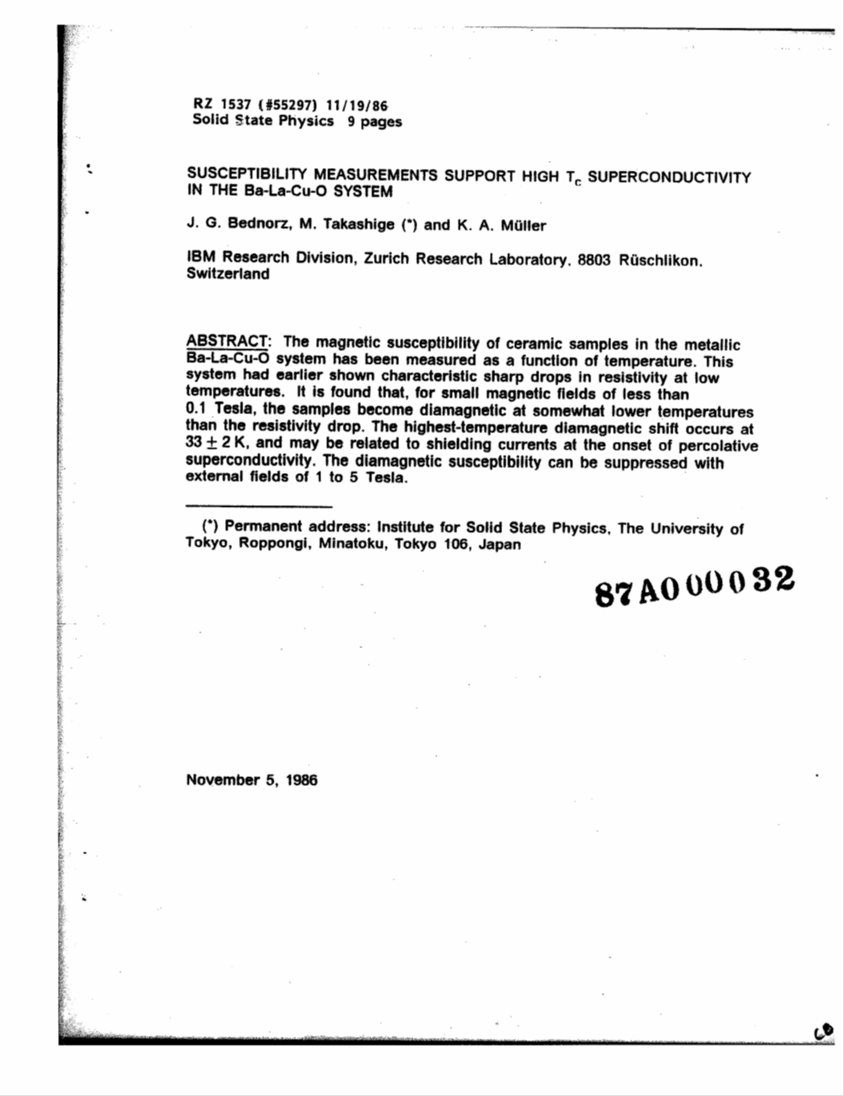

1. The first “official” IBM internal report written in mid-September, 1986 (concerning the January discovery), and on acceptance after submission, 12 November by Europhysics Letters, appeared in its 1 February 1987 issue9, establishing that Bednorz-Mueller were indeed the first to verify their own discovery.

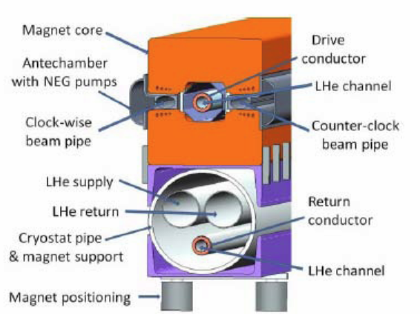

**YBCO**

2. The “Pipetron Vision” proposed by Fermilab in 2001 by Limon, Malamud and Foster20, and modified by Cooley21 in 2011 to incorporate HTSC superconducting cables. Note that at LHe temperatures, the critical state parameters of YBCO exceed those of all traditional A15 compounds employed in the past.

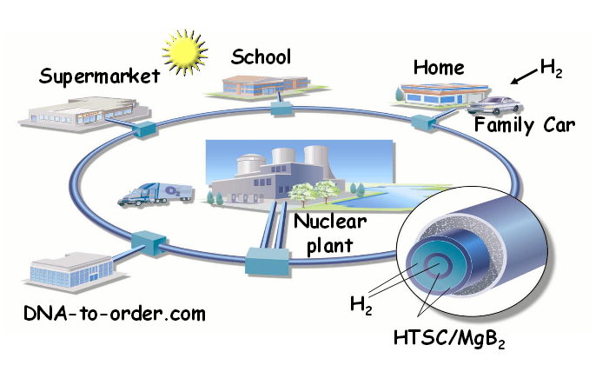

3. The “SuperGrid Vision” proposed by Grant and his EPRI colleagues in 2002.22 The embodiment shown above is that of a “SuperCity” or “SuperSuburb,” but can also be envisioned as the model for a Global Energy SuperGrid.

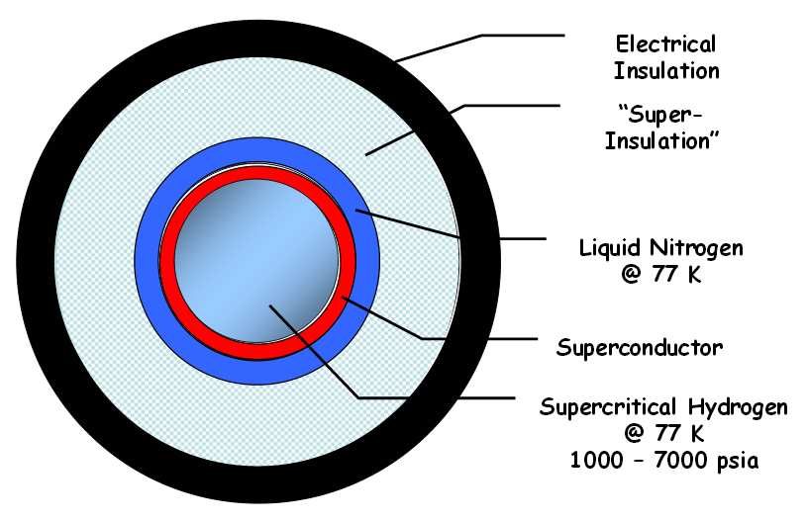

4. Cross-section of a possible “SuperCable” design to enable a Global Energy SuperGrid.22 Note the multiplicity of designs, all implying co-refrigeration by an appropriate state of hydrogen, to be consumed as fuel at cable termination point.

Suggested Author Photos

